**67577 Intro to Machine Learning Guy Lutsker 207029448**









1. 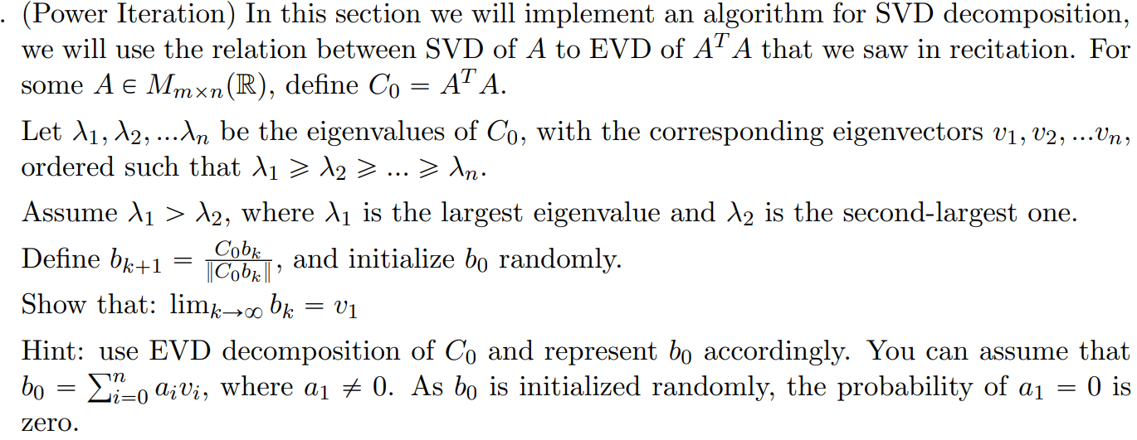

.

1. 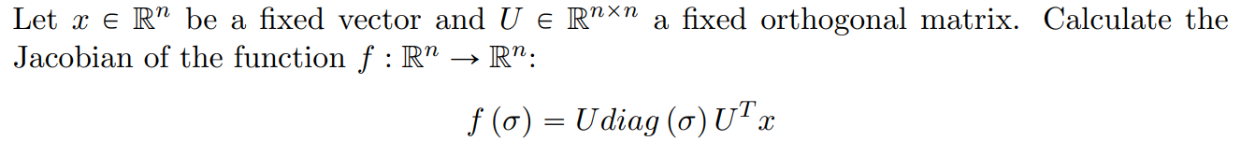

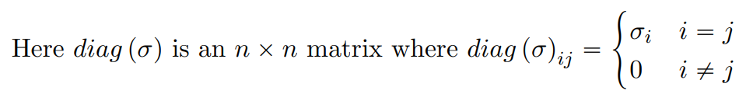







Plot:

: 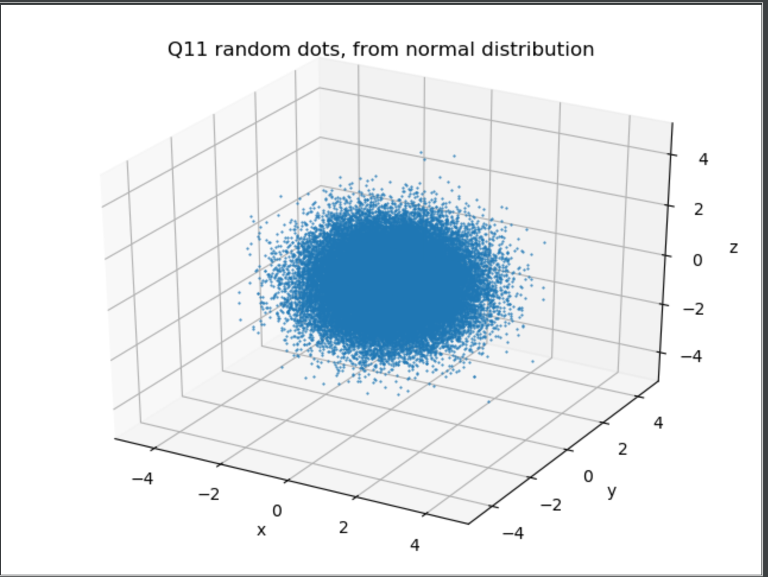

1. Transformed data with scaling matrix

Analytical Cov matrix we will define as =

Numerical Cov matrix =

Plot:

: 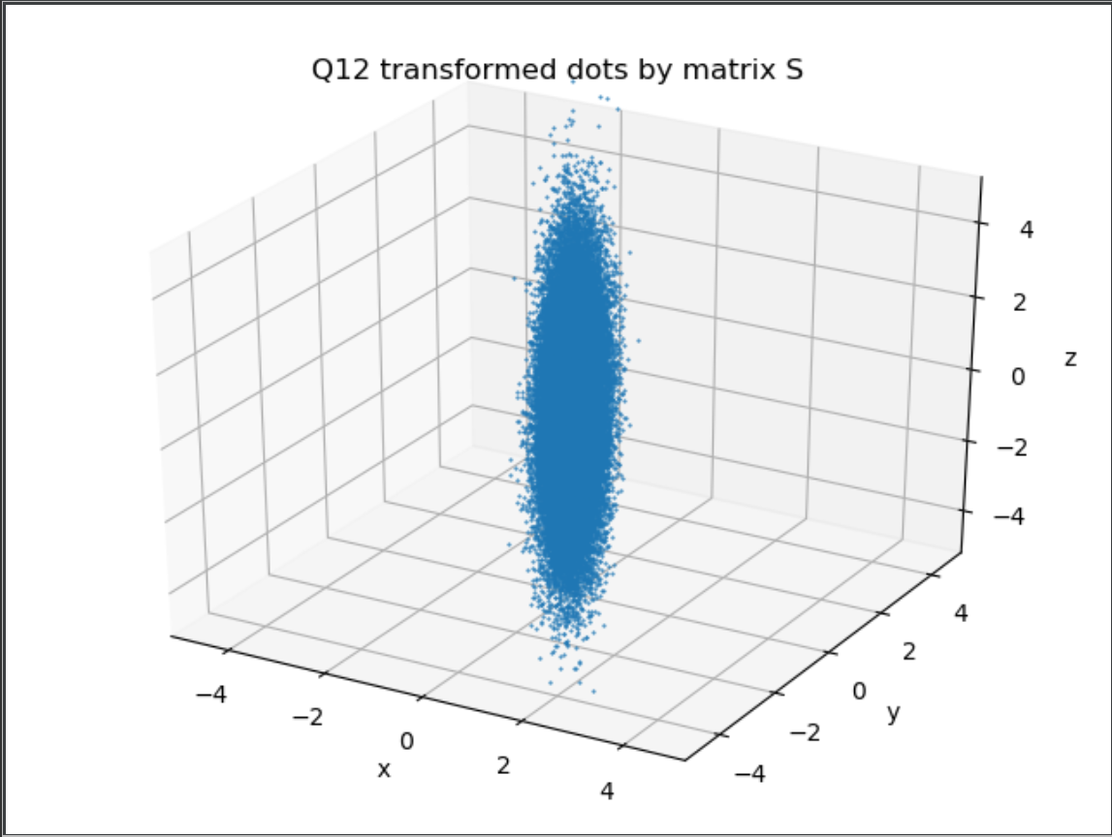

1. The random matrix I got:

Analytical Cov matrix we will define as

Numerical Cov matrix =

Plot:

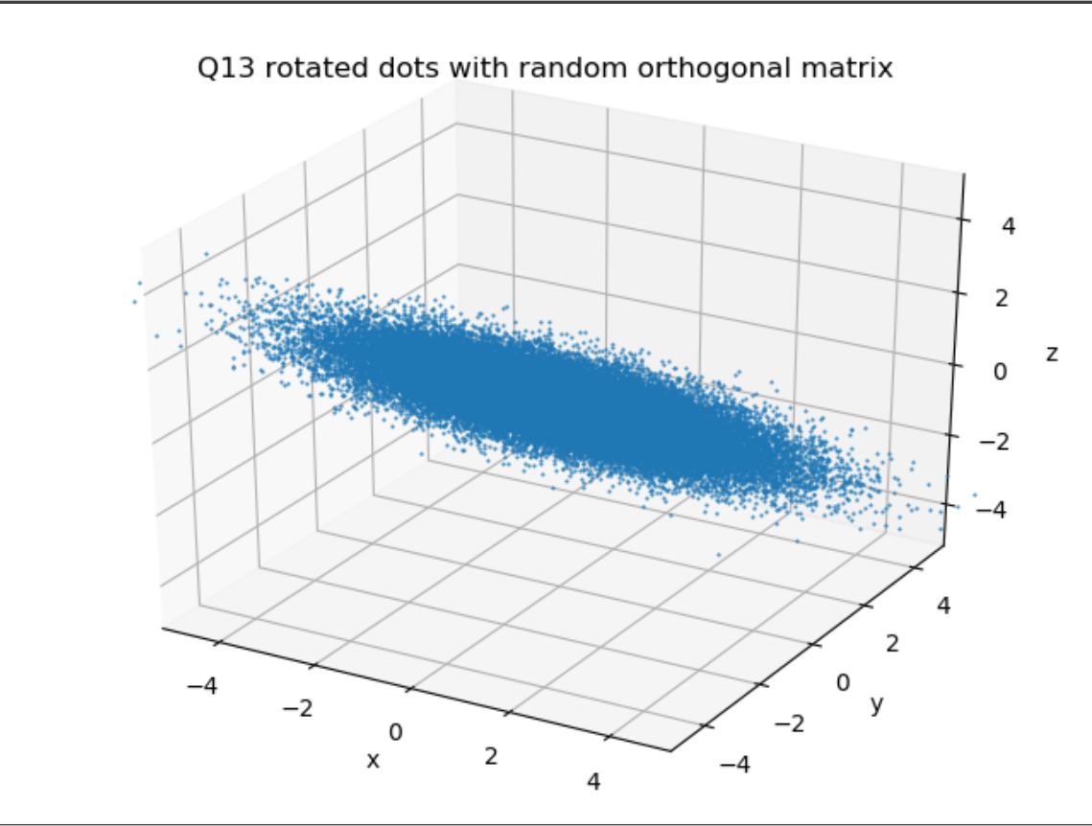

1. Plot of the previous data set projected onto the XY plane:  
   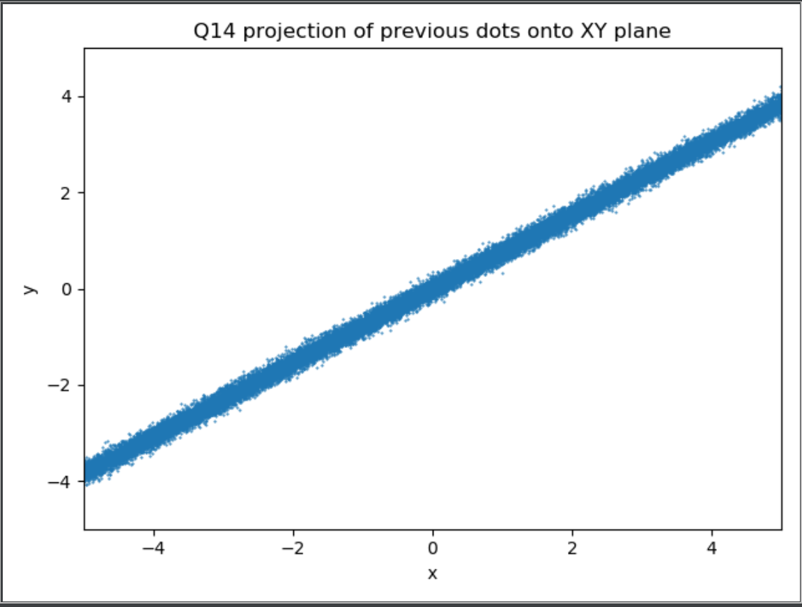
2. Same plot as question 14 but only for Z values s.t

Plot:

1. a.   
    Plot of the first 5 sequences of 1000 tosses, s.t the plot shown the relationship  
    between m(mean of tosses up to m) and the average of the sequences.

We would expect that as m grows the averages will converge, as the Weak Law of Large Numbers says, and indeed:

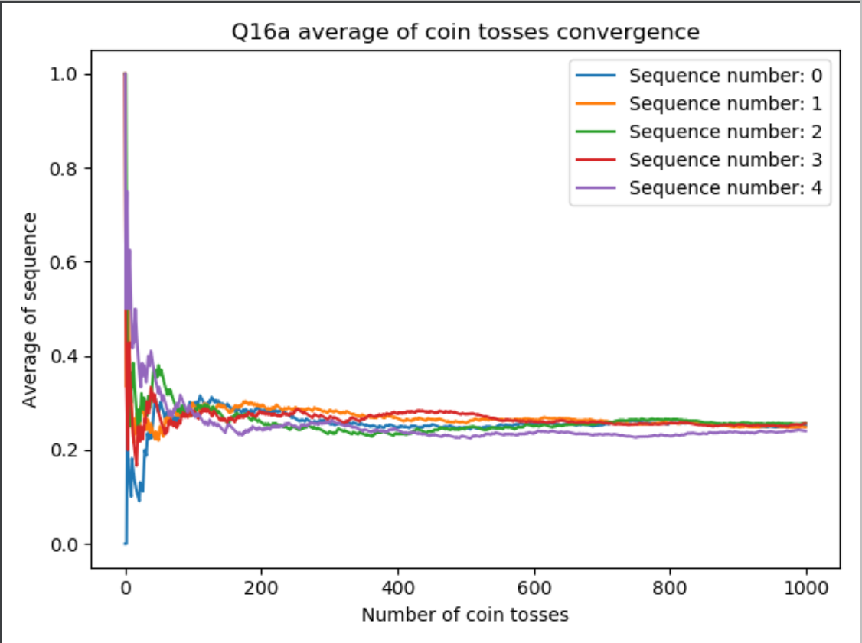

b. + c.: The plots I got in questions 16b and 16c:

I expect that as m grows the percentage of sequences that hold the claim will decrease.

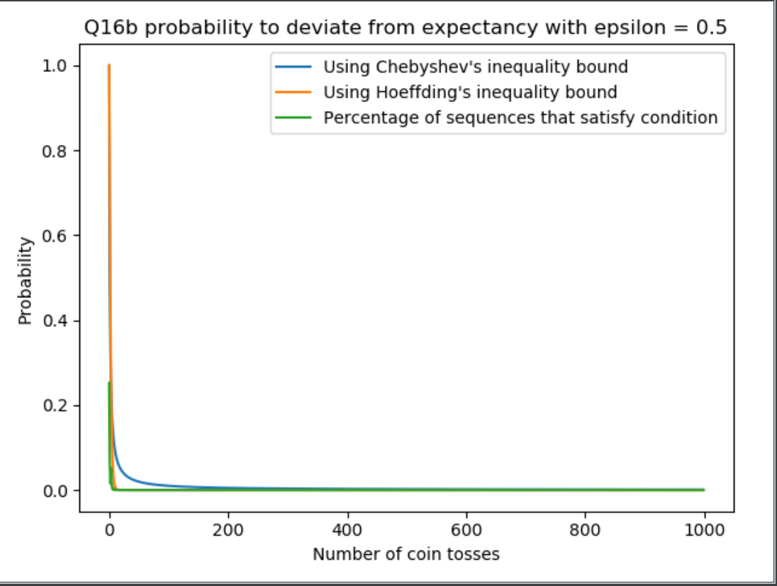

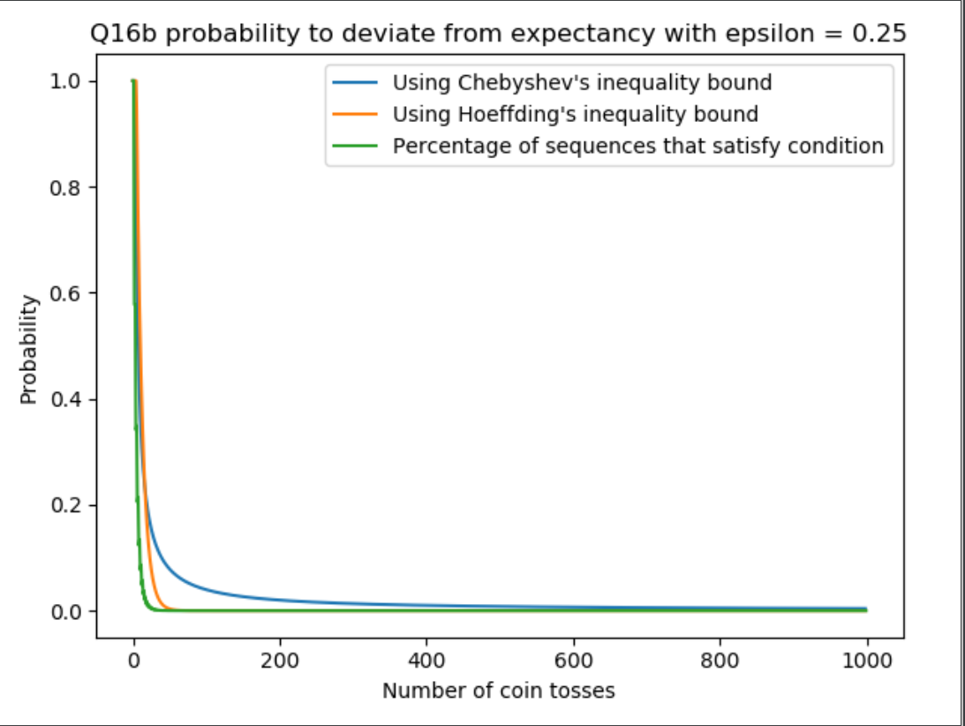

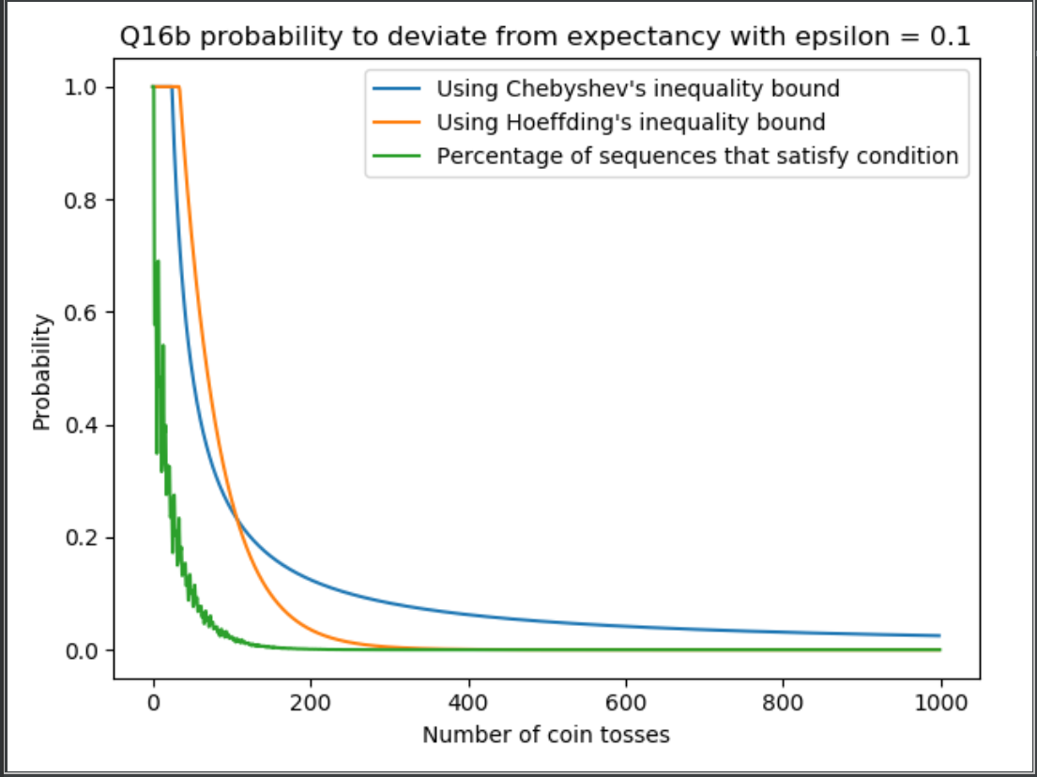

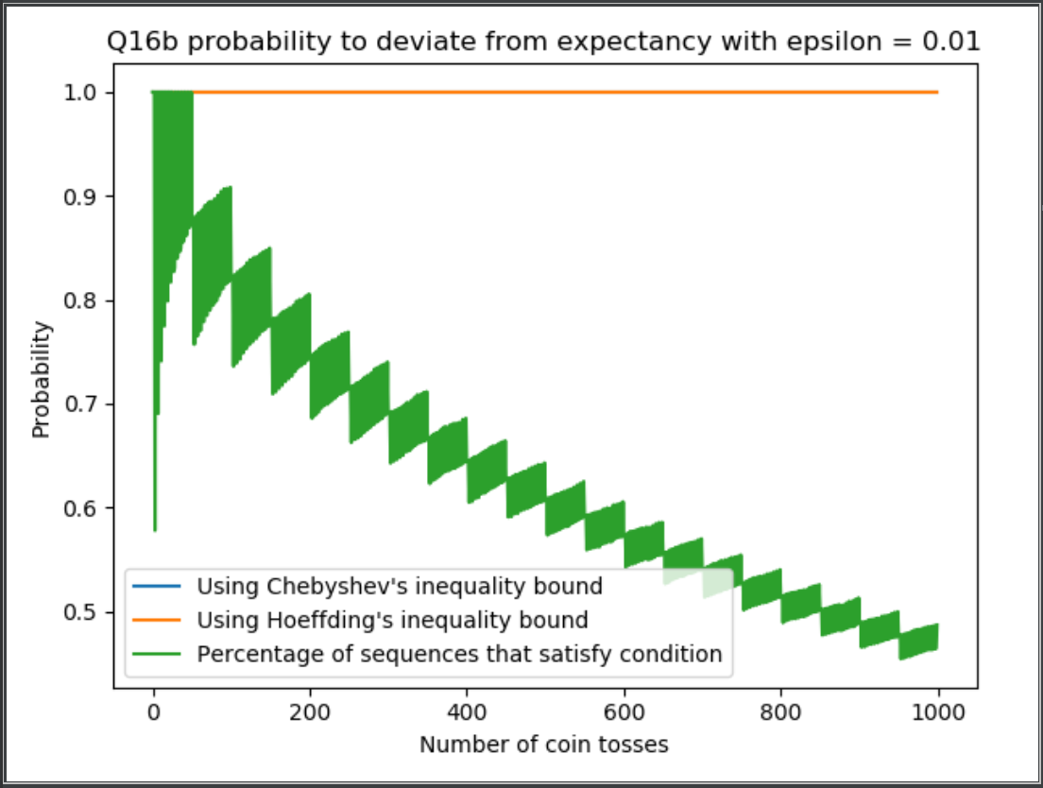

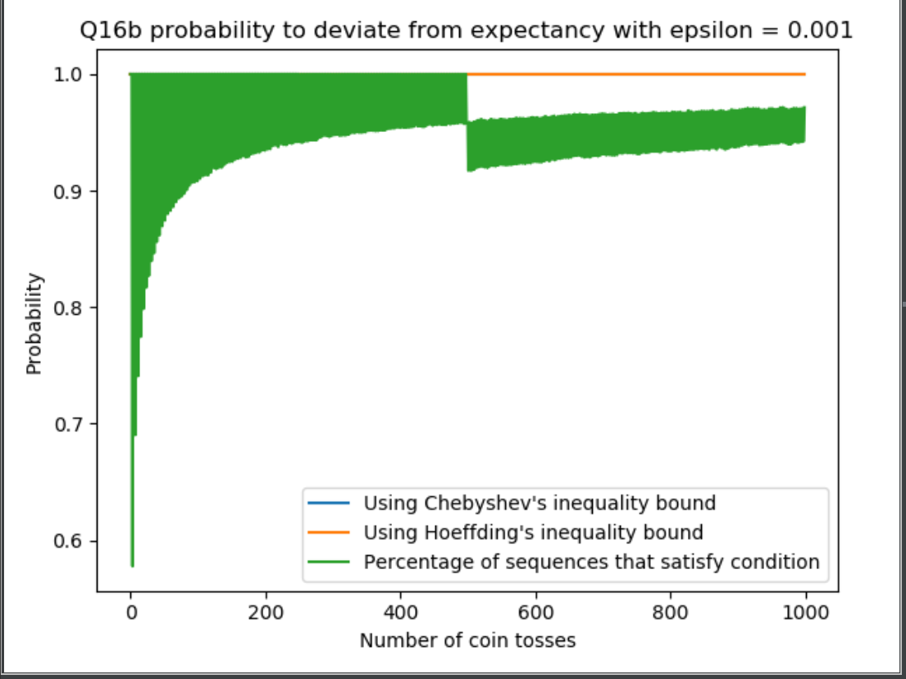

(for clarity in the last 2 graphs the bound (orange& blue) the line is pretty much set only to 1)